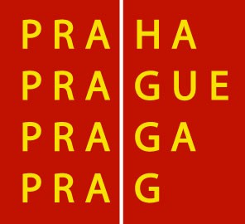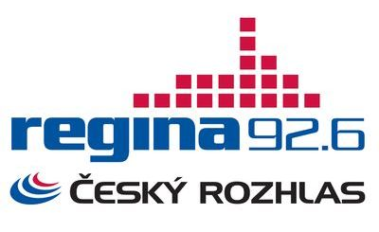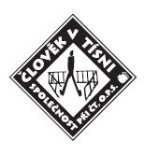

Press Release
Prague, January 19, 2010

HELP HAITI

The capital city of Prague, Czech Television, Czech Radio – Regina, and the non-governmental organisation People in Need have organised a humanitarian concert to help the Haiti earthquake victims. The concert took place on 21 January between 13hr and 21hr at the Prague’s Old Town Square and the programme consisted of well-known Czech musicians and prominent guests.

The city mayor of Prague Mr. Pavel Bém, Consul General of Dominican Republic Mr. Ramon Carreňo and other deputies of Latin American countries came to invite the visitors of the concert to support the Haiti earthquake victims.

Czech Radio – Regina provided live transmissions from the concert during the afternoon and after 20hr the station broadcasted the full programme live.

Czech Television broadcasted the full concert during the news broadcasting at its station CT24.

Czech Radio has recorded the complete concert and the edited version of the recording is incorporated into the broadcasting on Saturday 23 January at Czech Radio 1 – Radiozurnal.

These activities are complemented by a fundraising collection Help Haiti facilitated by the non-governmental organisation People in Need. Contributions can be provided in a form of DMS SOSHAITI at the number 87777.

On behalf of Czech Radio - Regina
PhDr. Josef Havel, director
Karel Zajíc, editor-in-chief

Další informace o Českém rozhlase naleznete
na stránkách Servisu pro novináře
W W W. R O Z H L A S. C Z / P R E S S

