Announcement
Prague, July 23, 2009

RICHARD MEDEK WAS APPOINTED
INTERIM DIRECTOR GENERAL OF CZECH RADIO

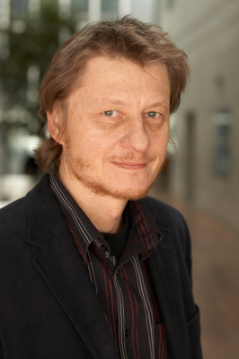
The Czech Radio Council has yesterday, 22nd July 2009, dismissed Czech Radio Director General Václav Kasík and appointed Richard Medek the Interim Director General.
Richard Medek, who has held the position of Czech Radio Programming Director, will be entrusted with the function until the selective procedure for a regular Director General will be finalised.

In his press release, Richard Medek thanked Václav Kasík for his ten-year activity in the position of Director General and for his accomplishments at Czech Radio. He sees his role of the Interim Director General as temporary and stabilising.

Richard Medek set as his priorities for this overarching period the preservation of the programme and economic stability of Czech Radio, further development of quality programme offer, elaboration of a detailed analysis of the extensive reconstruction of Czech Radio historic building and its current stage together with determining the strategy aiming at the fast completion of the works on the studio part of the building, securing profitable economic management of Czech Radio in 2009, preparation of the budget for 2010, and strengthening a positive image of Czech Radio. He will also continue to keep emphasis on the unbiased, objective and professional news coverage.

For further information, please contact:

Mgr. Rene Zavoral
Marketing and PR Director
Czech Radio
Phone. +420 22 155 1310, mobile: +420 606 768 610

